Integrate Playwright & Typescript
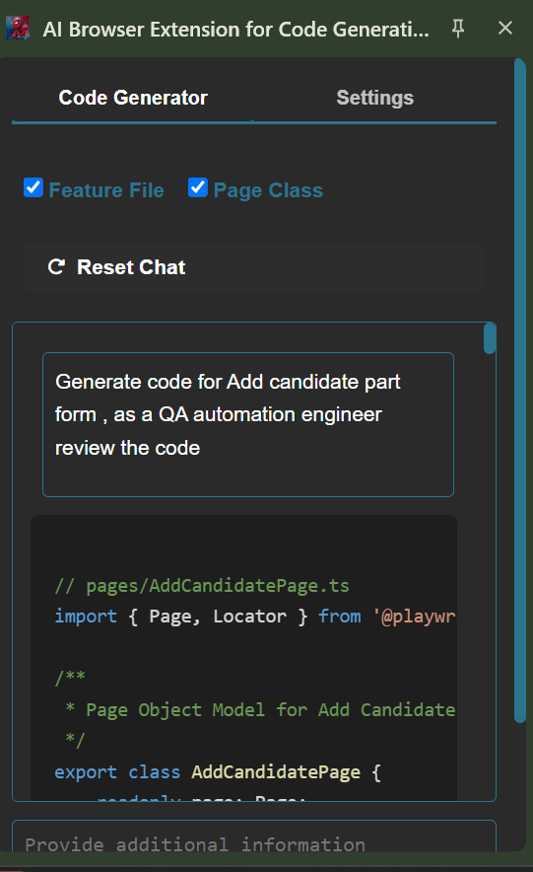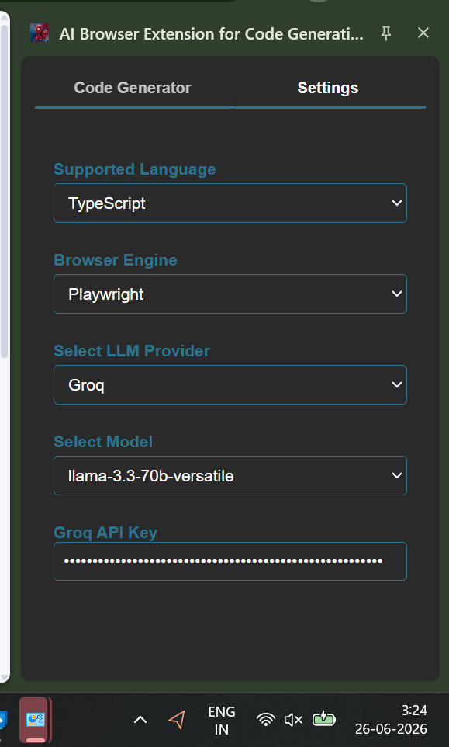
Generate a code base for Registration application - Add candidate
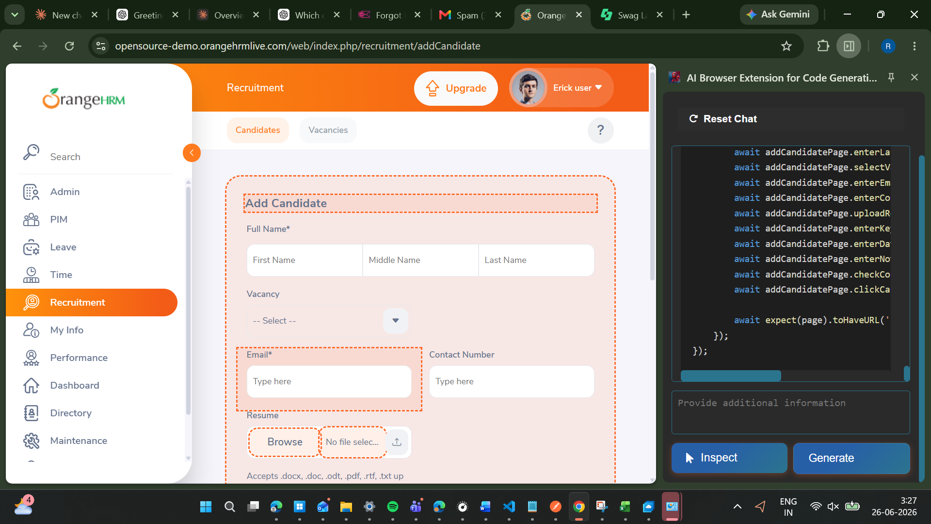
File 1
/ pages/AddCandidatePage.ts
import { Page, Locator } from '@playwright/test';

/**
* Page Object Model for Add Candidate page.
*/
export class AddCandidatePage {
readonly page: Page;
readonly firstNameInput: Locator;
readonly middleNameInput: Locator;
readonly lastNameInput: Locator;
readonly vacancySelect: Locator;
readonly emailInput: Locator;
readonly contactNumberInput: Locator;
readonly resumeInput: Locator;
readonly keywordsInput: Locator;
readonly dateOfApplicationInput: Locator;
readonly notesInput: Locator;
readonly consentToKeepDataCheckbox: Locator;
readonly saveButton: Locator;
readonly cancelButton: Locator;

/**
* Constructor for AddCandidatePage.
* @param page - The Playwright page object.
*/
constructor(page: Page) {
this.page = page;
this.firstNameInput = page.locator('input[name="firstName"]');
this.middleNameInput = page.locator('input[name="middleName"]');
this.lastNameInput = page.locator('input[name="lastName"]');
this.vacancySelect = page.locator('.oxd-select-text-input');
this.emailInput = page.locator('input[placeholder="Type here"]', { hasText: 'Email' });
this.contactNumberInput = page.locator('input[placeholder="Type here"]', { hasText: 'Contact Number' });
this.resumeInput = page.locator('input[type="file"]');
this.keywordsInput = page.locator('input[placeholder="Enter comma seperated words..."]');
this.dateOfApplicationInput = page.locator('input[placeholder="yyyy-dd-mm"]');
this.notesInput = page.locator('textarea');
this.consentToKeepDataCheckbox = page.locator('input[type="checkbox"]');
this.saveButton = page.locator('button:has-text("Save")');
this.cancelButton = page.locator('button:has-text("Cancel")');
}

/**
* Navigate to the Add Candidate page.
*/
async goto(): Promise<void> {
await this.page.goto('https://opensource-demo.orangehrmlive.com/web/index.php/recruitment/addCandidate');
}

/**
* Enter the first name of the candidate.
* @param firstName - The first name of the candidate.
*/
async enterFirstName(firstName: string): Promise<void> {
await this.firstNameInput.fill(firstName);
}

/**
* Enter the middle name of the candidate.
* @param middleName - The middle name of the candidate.
*/
async enterMiddleName(middleName: string): Promise<void> {
await this.middleNameInput.fill(middleName);
}

/**
* Enter the last name of the candidate.
* @param lastName - The last name of the candidate.
*/
async enterLastName(lastName: string): Promise<void> {
await this.lastNameInput.fill(lastName);
}

/**
* Select the vacancy for the candidate.
* @param vacancy - The vacancy to be selected.
*/
async selectVacancy(vacancy: string): Promise<void> {
await this.vacancySelect.click();
await this.page.locator(`div:has-text("${vacancy}")`).click();
}

/**
* Enter the email of the candidate.
* @param email - The email of the candidate.
*/
async enterEmail(email: string): Promise<void> {
await this.emailInput.fill(email);
}

/**
* Enter the contact number of the candidate.
* @param contactNumber - The contact number of the candidate.
*/
async enterContactNumber(contactNumber: string): Promise<void> {
await this.contactNumberInput.fill(contactNumber);
}

/**
* Upload the resume of the candidate.
* @param resumePath - The path to the resume file.
*/
async uploadResume(resumePath: string): Promise<void> {
await this.resumeInput.setInputFiles(resumePath);
}

/**
* Enter the keywords for the candidate.
* @param keywords - The keywords for the candidate.
*/
async enterKeywords(keywords: string): Promise<void> {
await this.keywordsInput.fill(keywords);
}

/**
* Enter the date of application for the candidate.
* @param dateOfApplication - The date of application for the candidate.
*/
async enterDateOfApplication(dateOfApplication: string): Promise<void> {
await this.dateOfApplicationInput.fill(dateOfApplication);
}

/**
* Enter the notes for the candidate.
* @param notes - The notes for the candidate.
*/
async enterNotes(notes: string): Promise<void> {
await this.notesInput.fill(notes);
}

/**
* Check the consent to keep data checkbox.
*/
async checkConsentToKeepData(): Promise<void> {
await this.consentToKeepDataCheckbox.check();
}

/**
* Click the save button.
*/
async clickSave(): Promise<void> {
await this.saveButton.click();
}

/**
* Click the cancel button.
*/
async clickCancel(): Promise<void> {
await this.cancelButton.click();
}
}

// tests/addCandidate.spec.ts
import { test, expect, Page } from '@playwright/test';
import { AddCandidatePage } from '../pages/AddCandidatePage';

test.describe('Add Candidate', () => {
let page: Page;
let addCandidatePage: AddCandidatePage;

test.beforeEach(async ({ page: testPage }) => {
page = testPage;
addCandidatePage = new AddCandidatePage(page);
await addCandidatePage.goto();
});

test('Add candidate with valid details', async () => {
await addCandidatePage.enterFirstName('Rahul');
await addCandidatePage.enterMiddleName('Kumar');
await addCandidatePage.enterLastName('Sharma');
await addCandidatePage.selectVacancy('Software Engineer');
await addCandidatePage.enterEmail('rahul@example.com');
await addCandidatePage.enterContactNumber('1234567890');
await addCandidatePage.uploadResume('path/to/resume.pdf');
await addCandidatePage.enterKeywords('software engineer, java, python');
await addCandidatePage.enterDateOfApplication('2022-01-01');
await addCandidatePage.enterNotes('This is a test candidate');
await addCandidatePage.checkConsentToKeepData();
await addCandidatePage.clickSave();

await expect(page).toHaveURL('**/viewCandidate');
});

test('Add candidate with invalid email', async () => {
await addCandidatePage.enterFirstName('Rahul');
await addCandidatePage.enterMiddleName('Kumar');
await addCandidatePage.enterLastName('Sharma');
await addCandidatePage.selectVacancy('Software Engineer');
await addCandidatePage.enterEmail('invalid-email');
await addCandidatePage.enterContactNumber('1234567890');
await addCandidatePage.uploadResume('path/to/resume.pdf');
await addCandidatePage.enterKeywords('software engineer, java, python');
await addCandidatePage.enterDateOfApplication('2022-01-01');
await addCandidatePage.enterNotes('This is a test candidate');
await addCandidatePage.checkConsentToKeepData();
await addCandidatePage.clickSave();

await expect(page).toHaveURL('**/addCandidate');
});

test('Cancel adding candidate', async () => {
await addCandidatePage.enterFirstName('Rahul');
await addCandidatePage.enterMiddleName('Kumar');
await addCandidatePage.enterLastName('Sharma');
await addCandidatePage.selectVacancy('Software Engineer');
await addCandidatePage.enterEmail('rahul@example.com');
await addCandidatePage.enterContactNumber('1234567890');
await addCandidatePage.uploadResume('path/to/resume.pdf');
await addCandidatePage.enterKeywords('software engineer, java, python');
await addCandidatePage.enterDateOfApplication('2022-01-01');
await addCandidatePage.enterNotes('This is a test candidate');
await addCandidatePage.checkConsentToKeepData();
await addCandidatePage.clickCancel();

await expect(page).toHaveURL('**/viewCandidates');
});
});

File 2
/ tests/addCandidate.spec.ts
import { test, expect, Page } from '@playwright/test';
import { AddCandidatePage } from '../pages/AddCandidatePage';

test.describe('Add Candidate', () => {
let page: Page;
let addCandidatePage: AddCandidatePage;

test.beforeEach(async ({ page: testPage }) => {
page = testPage;
addCandidatePage = new AddCandidatePage(page);
await addCandidatePage.goto();
});

test('Add candidate with valid details', async () => {
await addCandidatePage.enterFirstName('Rahul');
await addCandidatePage.enterMiddleName('Kumar');
await addCandidatePage.enterLastName('Sharma');
await addCandidatePage.selectVacancy('Software Engineer');
await addCandidatePage.enterEmail('rahul@example.com');
await addCandidatePage.enterContactNumber('1234567890');
await addCandidatePage.uploadResume('path/to/resume.pdf');
await addCandidatePage.enterKeywords('software engineer, java, python');
await addCandidatePage.enterDateOfApplication('2022-01-01');
await addCandidatePage.enterNotes('This is a test candidate');
await addCandidatePage.checkConsentToKeepData();
await addCandidatePage.clickSave();

await expect(page).toHaveURL('**/viewCandidate');
});

test('Add candidate with invalid email', async () => {
await addCandidatePage.enterFirstName('Rahul');
await addCandidatePage.enterMiddleName('Kumar');
await addCandidatePage.enterLastName('Sharma');
await addCandidatePage.selectVacancy('Software Engineer');
await addCandidatePage.enterEmail('invalid-email');
await addCandidatePage.enterContactNumber('1234567890');
await addCandidatePage.uploadResume('path/to/resume.pdf');
await addCandidatePage.enterKeywords('software engineer, java, python');
await addCandidatePage.enterDateOfApplication('2022-01-01');
await addCandidatePage.enterNotes('This is a test candidate');
await addCandidatePage.checkConsentToKeepData();
await addCandidatePage.clickSave();

await expect(page).toHaveURL('**/addCandidate');
});

test('Cancel adding candidate', async () => {
await addCandidatePage.enterFirstName('Rahul');
await addCandidatePage.enterMiddleName('Kumar');
await addCandidatePage.enterLastName('Sharma');
await addCandidatePage.selectVacancy('Software Engineer');
await addCandidatePage.enterEmail('rahul@example.com');
await addCandidatePage.enterContactNumber('1234567890');
await addCandidatePage.uploadResume('path/to/resume.pdf');
await addCandidatePage.enterKeywords('software engineer, java, python');
await addCandidatePage.enterDateOfApplication('2022-01-01');
await addCandidatePage.enterNotes('This is a test candidate');
await addCandidatePage.checkConsentToKeepData();
await addCandidatePage.clickCancel();

await expect(page).toHaveURL('**/viewCandidates');
});
});

